OSL – WEEK 3

Q1)

#include <stdio.h>

#include <stdlib.h>

#include <sys/types.h>

#include <sys/wait.h>

#include <unistd.h>

int main() { printf("[*] Starting parent process\n");

int r_val = fork(); switch(r_val) { case -1: { perror("[*] fork\n"); exit(EXIT_FAILURE);

} break; case 0: { printf("[**] Inside child process\n"); for(int i = 0; i < 10; i++) { sleep(1);

printf("[**] Sleeping child for %d seconds...\

n", i + 1);

} exit(0);

} break; default: { printf("[*] Waiting for child\n"); wait(NULL);

printf("[*] Child process finished execution\n"); exit(0);

}

}

}

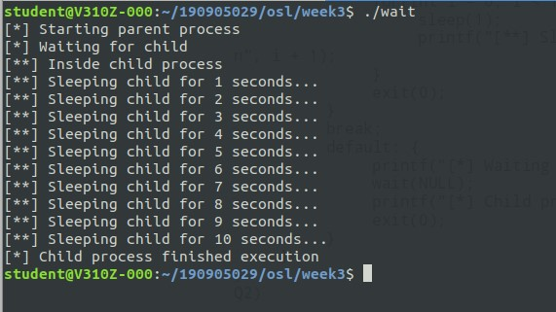

Q2)

#include <stdio.h>

#include <stdlib.h>

#include <sys/types.h>

#include <sys/wait.h>

#include <unistd.h>

int main() { printf("[*] Starting parent process\n"); int r_val = fork(); switch(r_val) { case -1: { perror("[*] fork\n"); exit(EXIT_FAILURE);

} break; case 0: { printf("[**] Inside child process\n"); printf("[**] Executing ./wait inside child\n"); execl("./wait", "./wait" , NULL);

exit(0);

} break; default: { printf("[*] Waiting for child\n"); wait(NULL);

printf("[*] Child process finished execution\n"); exit(0);

}

}

}

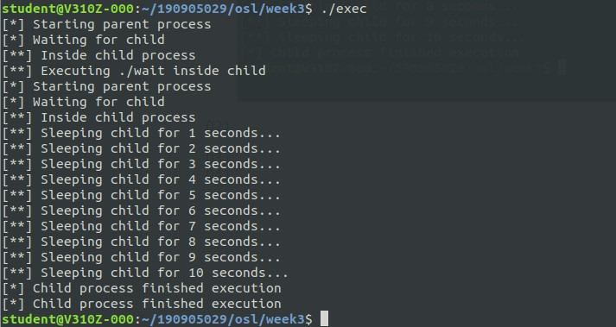

Q3)

#include <stdio.h>

#include <stdlib.h>

#include <sys/types.h>

#include <sys/wait.h>

#include <unistd.h>

int main() { printf("[*] Starting parent process\n"); int r_val = fork(); switch(r_val) { case -1: { perror("[*] fork\n"); exit(EXIT_FAILURE);

} break; case 0: { printf("[**] Inside child process\n");

pid_t curr_pid = getpid();

printf("[**] PID of child process: %d\n", curr_pid);

exit(0);

} break; default: { pid_t curr_pid = getpid();

printf("[*] PID of parent process: %d\n", curr_pid);

printf("[*] Waiting for child\n"); wait(NULL);

printf("[*] Child process finished execution\n"); exit(0);

}

}

}

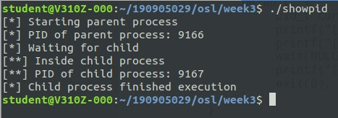

Q4)

#include <stdio.h>

#include <stdlib.h>

#include <sys/types.h>

#include <sys/wait.h>

#include <unistd.h>

int main() { printf("[*] Starting parent process\n"); int r_val = fork(); switch(r_val) { case -1: { perror("[*] fork\n"); exit(EXIT_FAILURE);

} break; case 0: { printf("[**] Inside child process\n");

pid_t curr_ppid = getppid();

printf("[**] Current parent: %d\n", curr_ppid);

for(int i = 0; i < 10; i++) { sleep(1);

printf("[**] Sleeping child for %d seconds...\

n", i + 1);

}

curr_ppid = getppid();

printf("[**] Current parent: %d\n", curr_ppid); exit(0);

} break; default: { printf("[**] Executing ps\n"); execl("/bin/ps", "ps", NULL); exit(0);

}

}

}

